**CONTENT ASSESSMENT 5**

**Name:** Naseer Almargan

**Date:** 15-06-2020

**Complete the following tasks using the sysbench performance benchmarking tool:**

**(a) Execute the sysbench CPU benchmark with 1, 2, 4, and 8 threads. You can change the thread count using the −−num-threads command. Set the max prime value to 5000. Comment on your thoughts about performance differences as you modify the thread count. Performance for this benchmark is measured in total time taken by event execution. Lower time is better.**

Ans:

The sysbench CPU benchmark with 1,2,4 and 8 threads are tested and the following results are concluded. ‘Increase in number of threads count increase the time of event execution’. So, we can say that the event execution time is proportional to the increase in number of threads. Increase in number of threads count takes more time for processing.

**(b) Paste the output of each run of the CPU benchmark at different thread counts.**

**Output of CPU benchmark at thread count=1:**

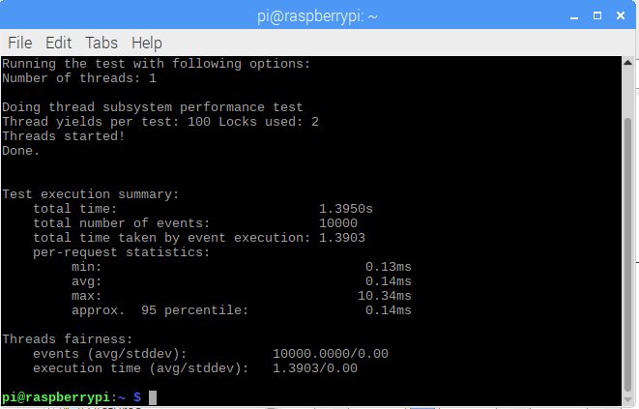

**Output of CPU benchmark at thread count=2:**

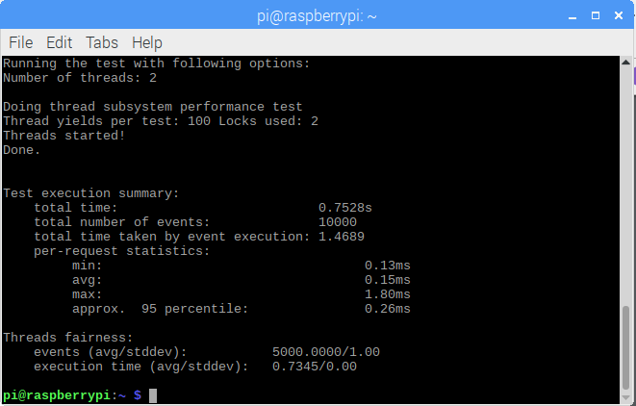

**Output of CPU benchmark at thread count=4:**

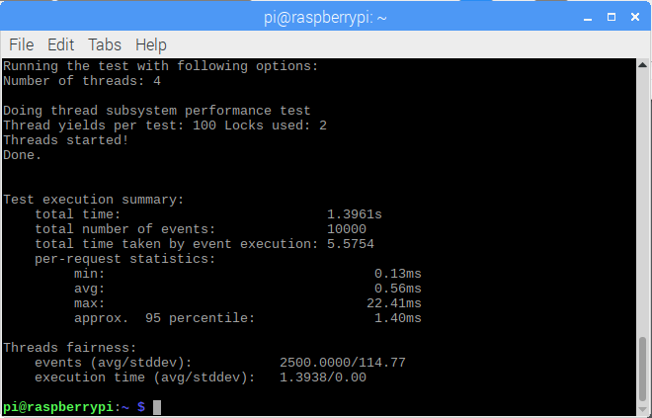

**Output of CPU benchmark at thread count=8:**

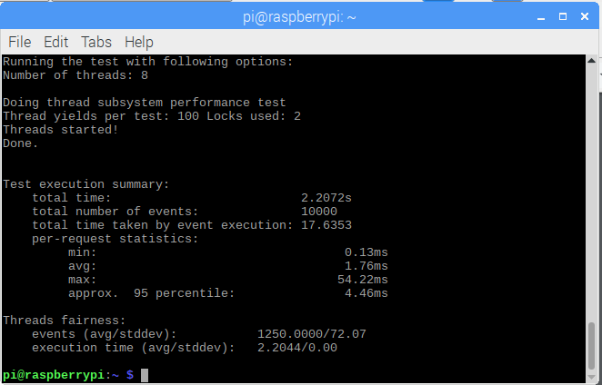

**(c) Execute the sysbench File IO benchmark with file sizes of 1GB, 2GB, 4GB, and 8GB. You can change the file size using the −−file-total-size command. Comment on your thoughts about the performance differences as you modify the file size. Performance for this benchmark is measured in kb/sec. You can find this metric in the Operations performed section of the benchmark output.**

**Ans:**

The sysbench file IO benchmark with file size 1GB,2GB,4GB and 8GB is executed. The result show that as the size of file IO increases the transferred rate in Kb/sec is decreasing. This is due to the increase in the memory of the file. As larger the file the more time is required because the transferring of data is slow.

**(d) Paste the output of each run of the File IO benchmark at different file sizes.**

**Benchmark output when file size 1GB:**

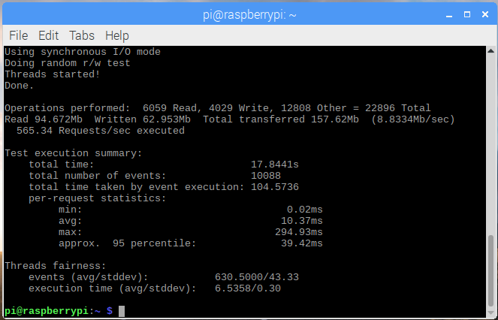

**Benchmark output when file size 2GB:**

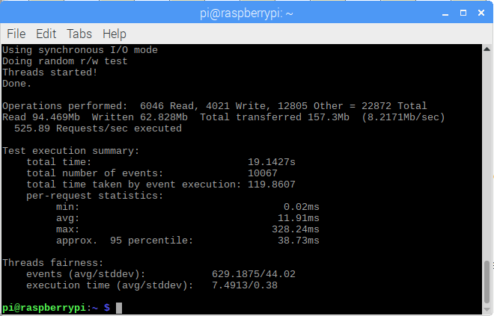

**Benchmark output when file size 4GB:**

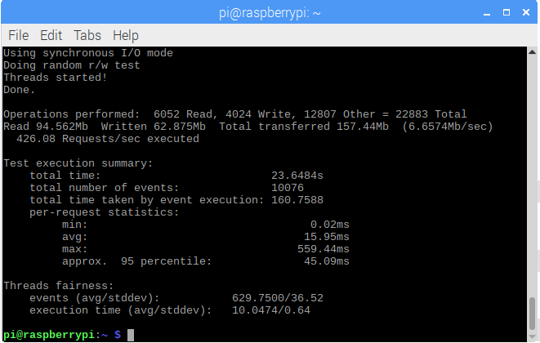

**Benchmark output when file size 8GB:**

